**Unit 9 Permissions**

Corey Crooks

Purdue University Global

IT234 – Leon King

July 14, 2021

Problem 1

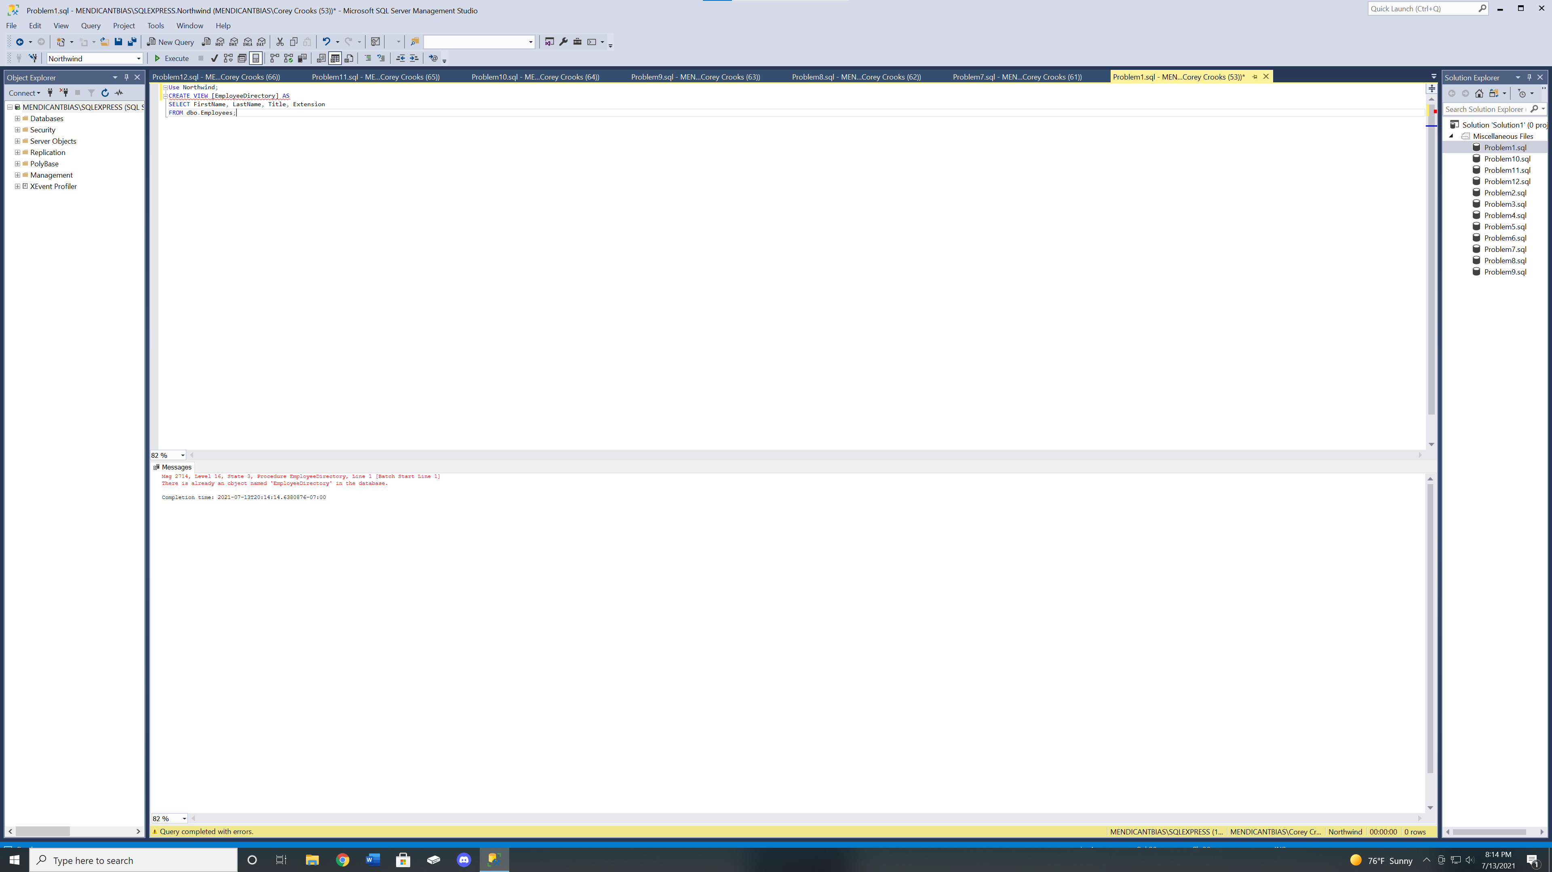

Problem 2

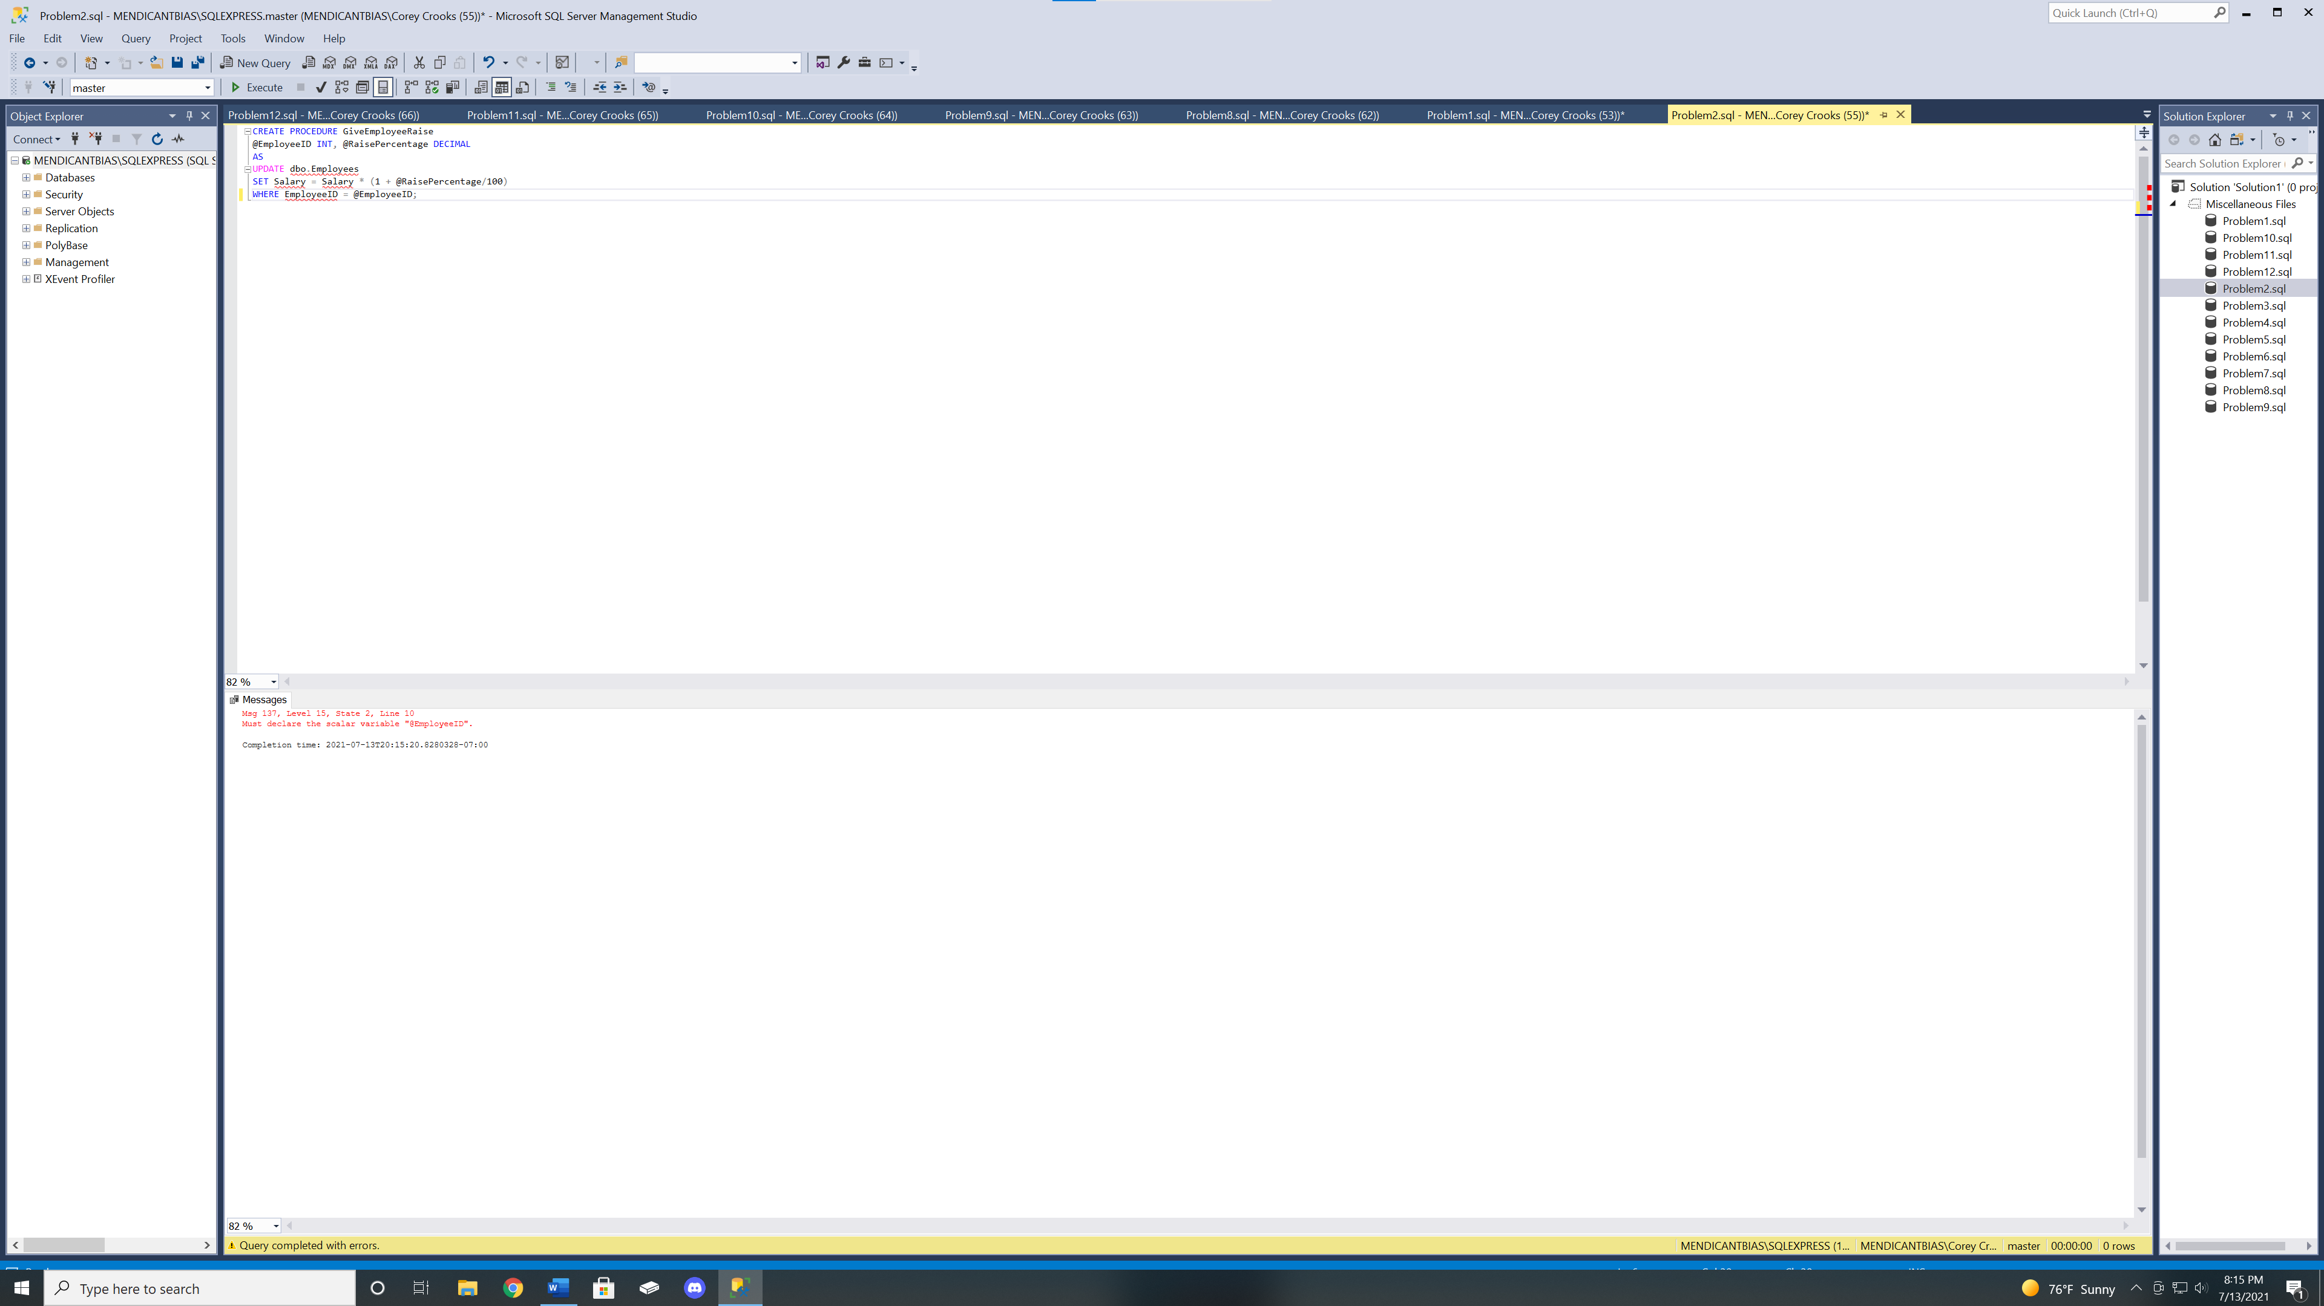

Problem 3

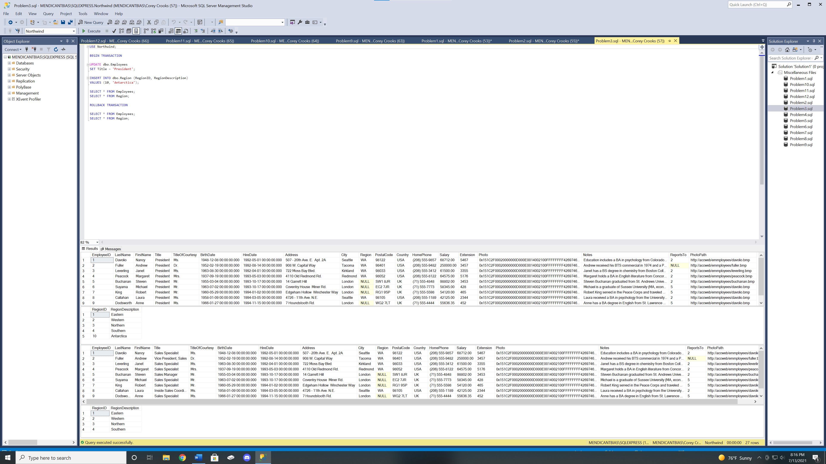

Problem 4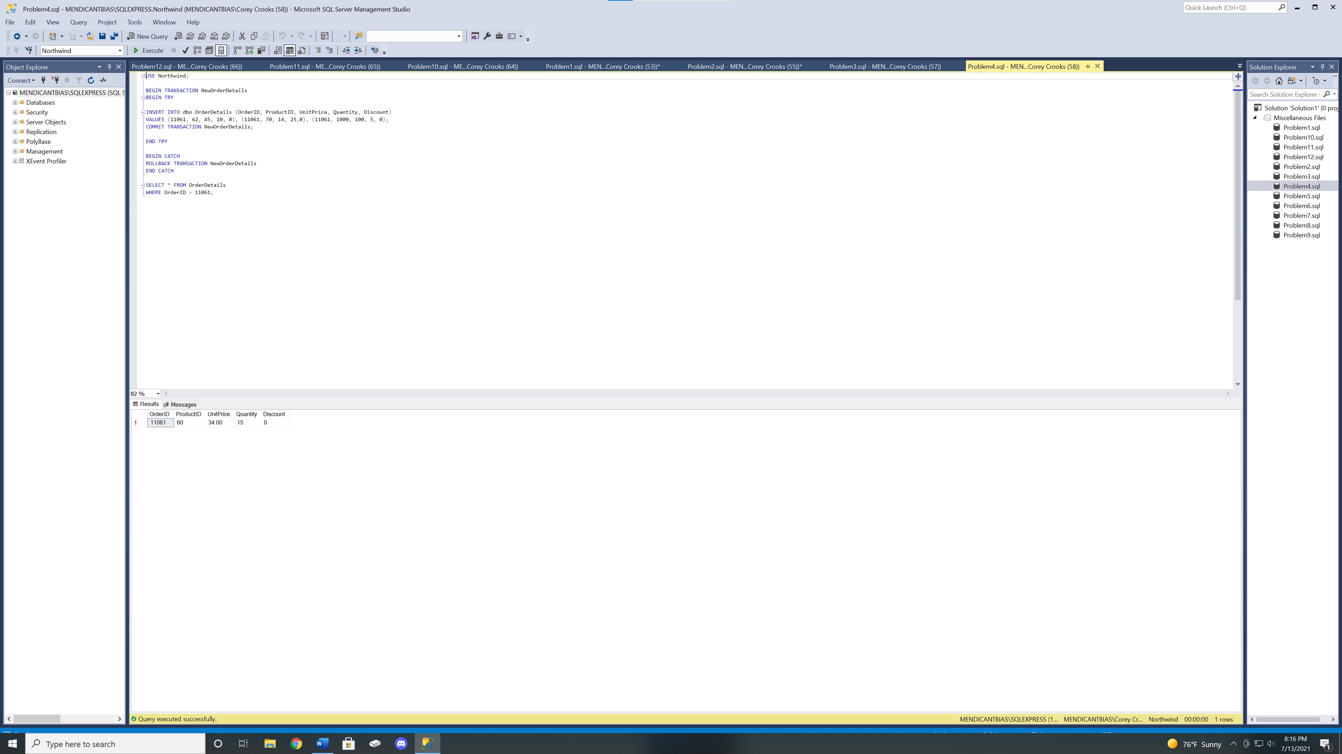

To explain the output, when running the INSERT INTO statement, you will get an error saying that the dataset conflicts with a foreign key constraint. You may have noticed that our 3 records were not added to the result set. This is because the error procced the TRY boundaries, and thus enacted the CATCH code. This CATCH code rolled back any changes made in the INSERT INTO clause enclosed in our TRY statement.

Problem 5

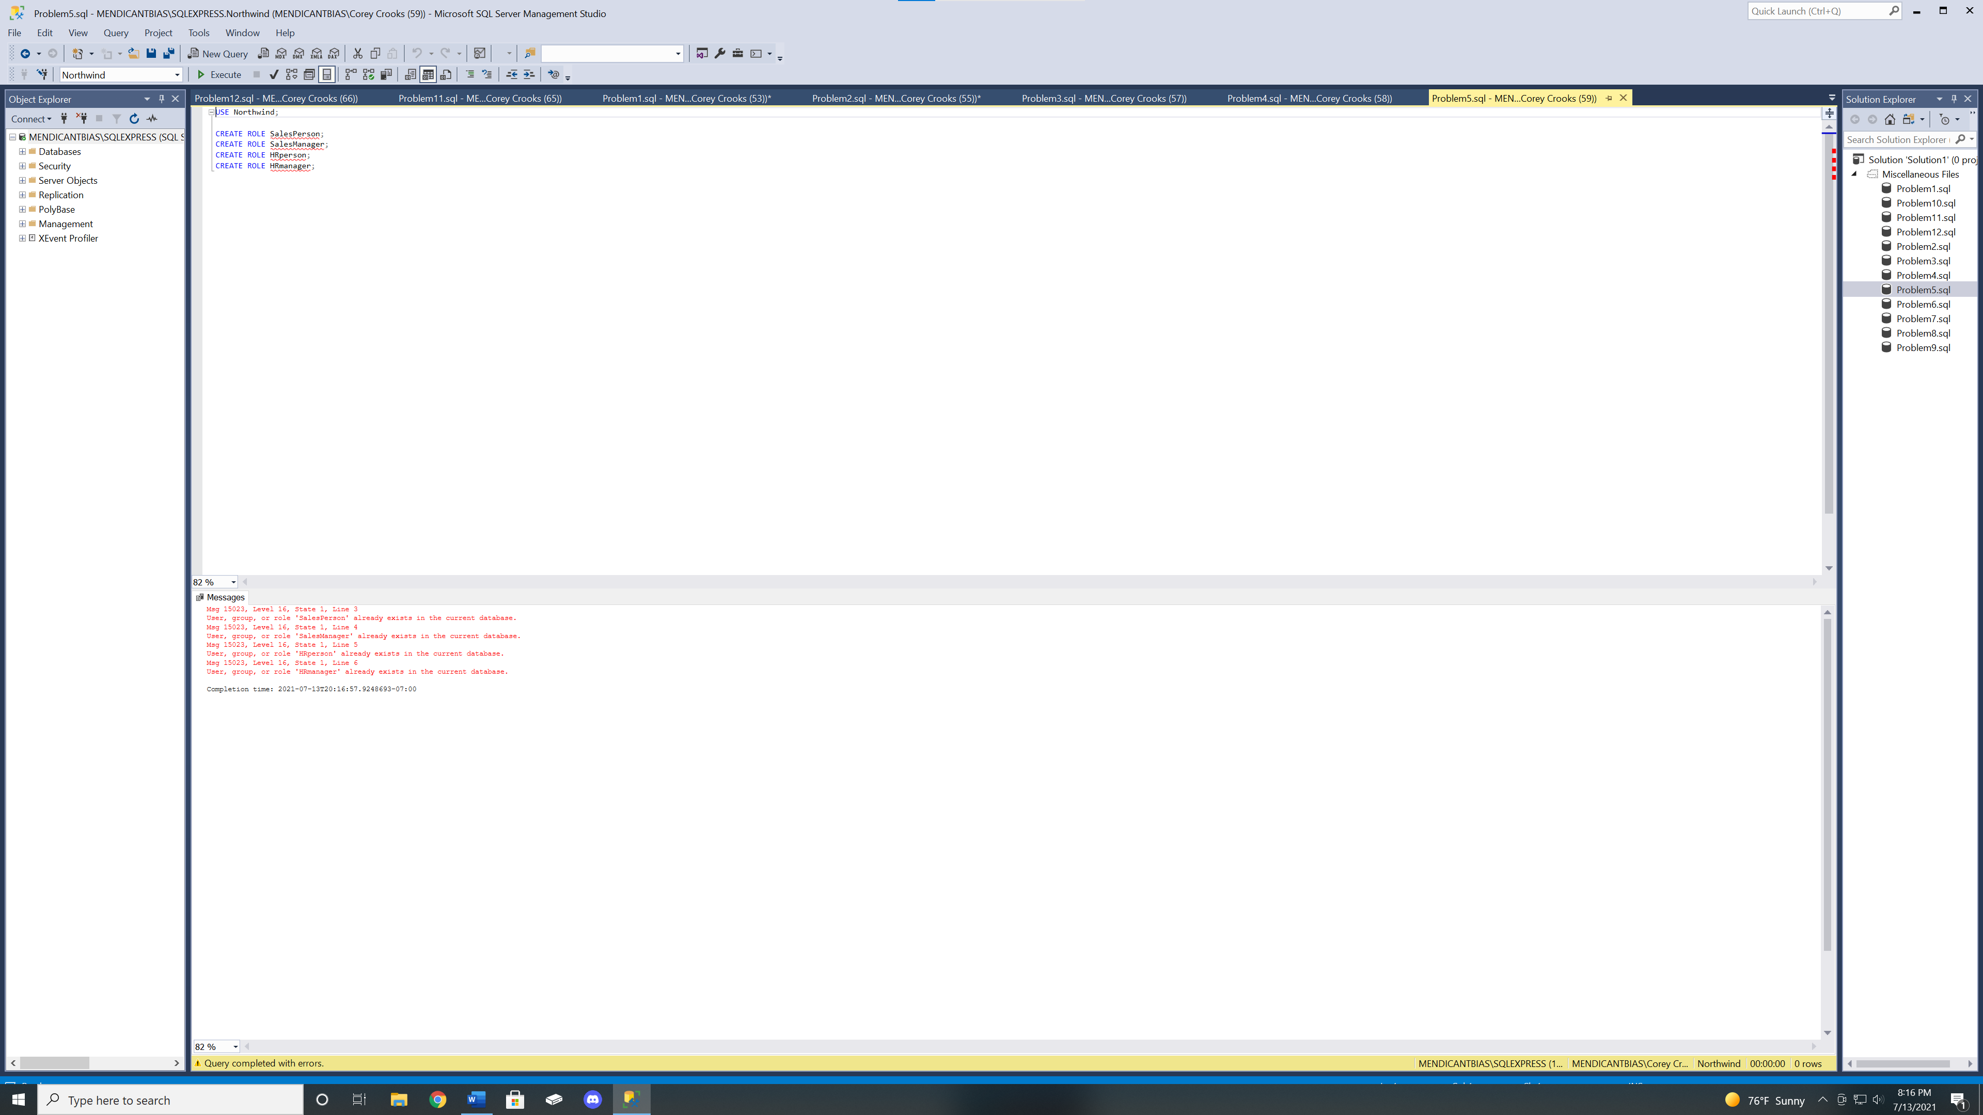

Problem 6

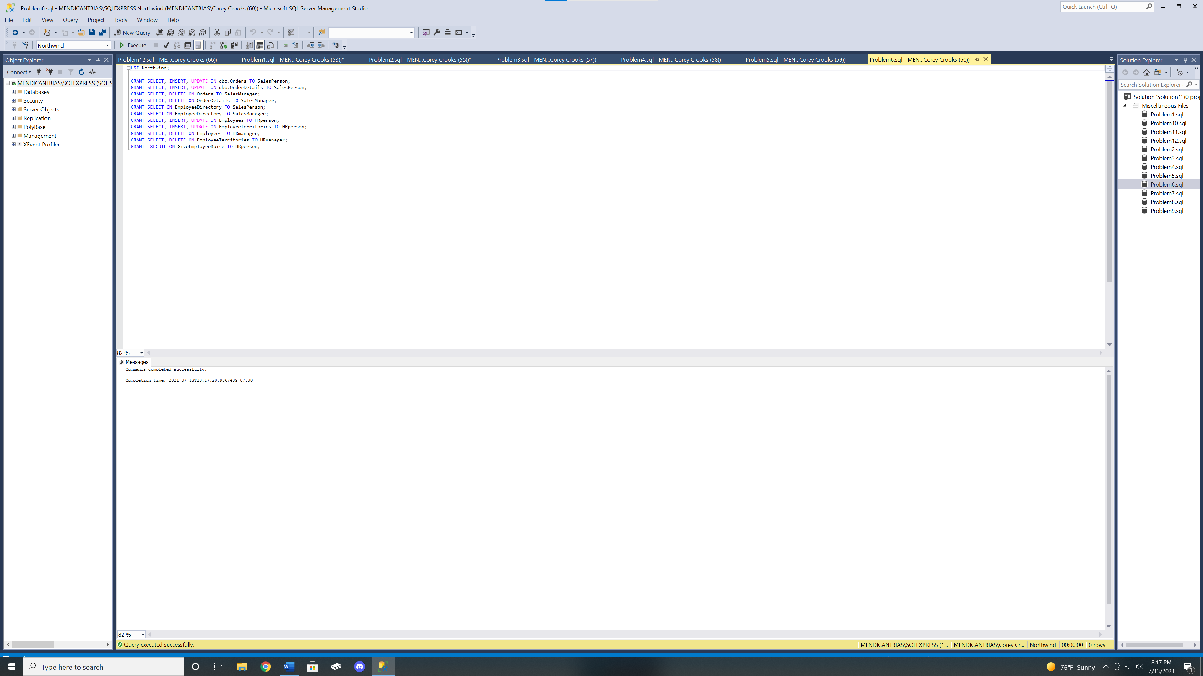

Problem 7

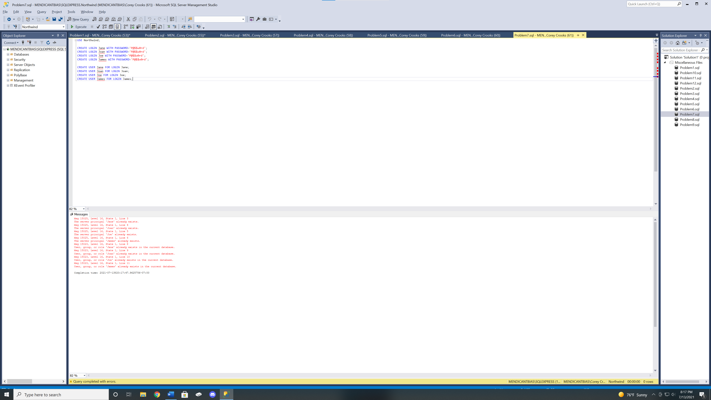

Problem 8

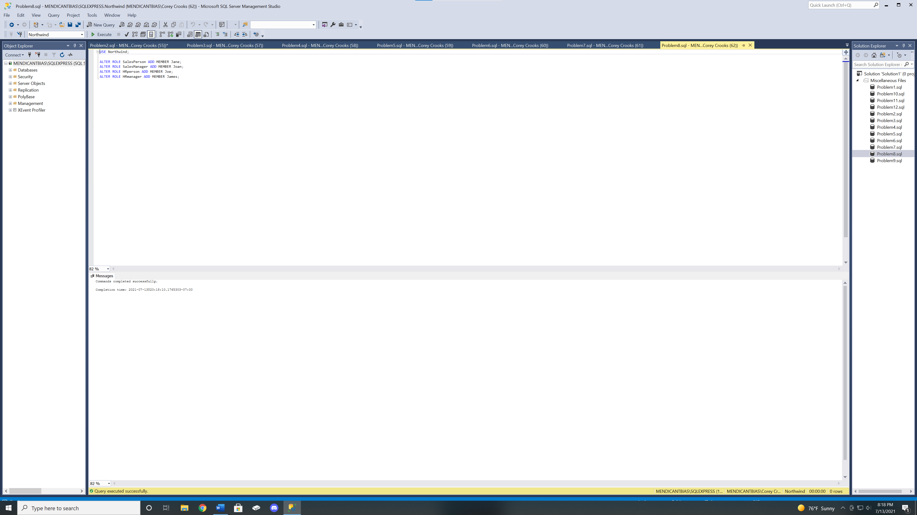

Problem 9

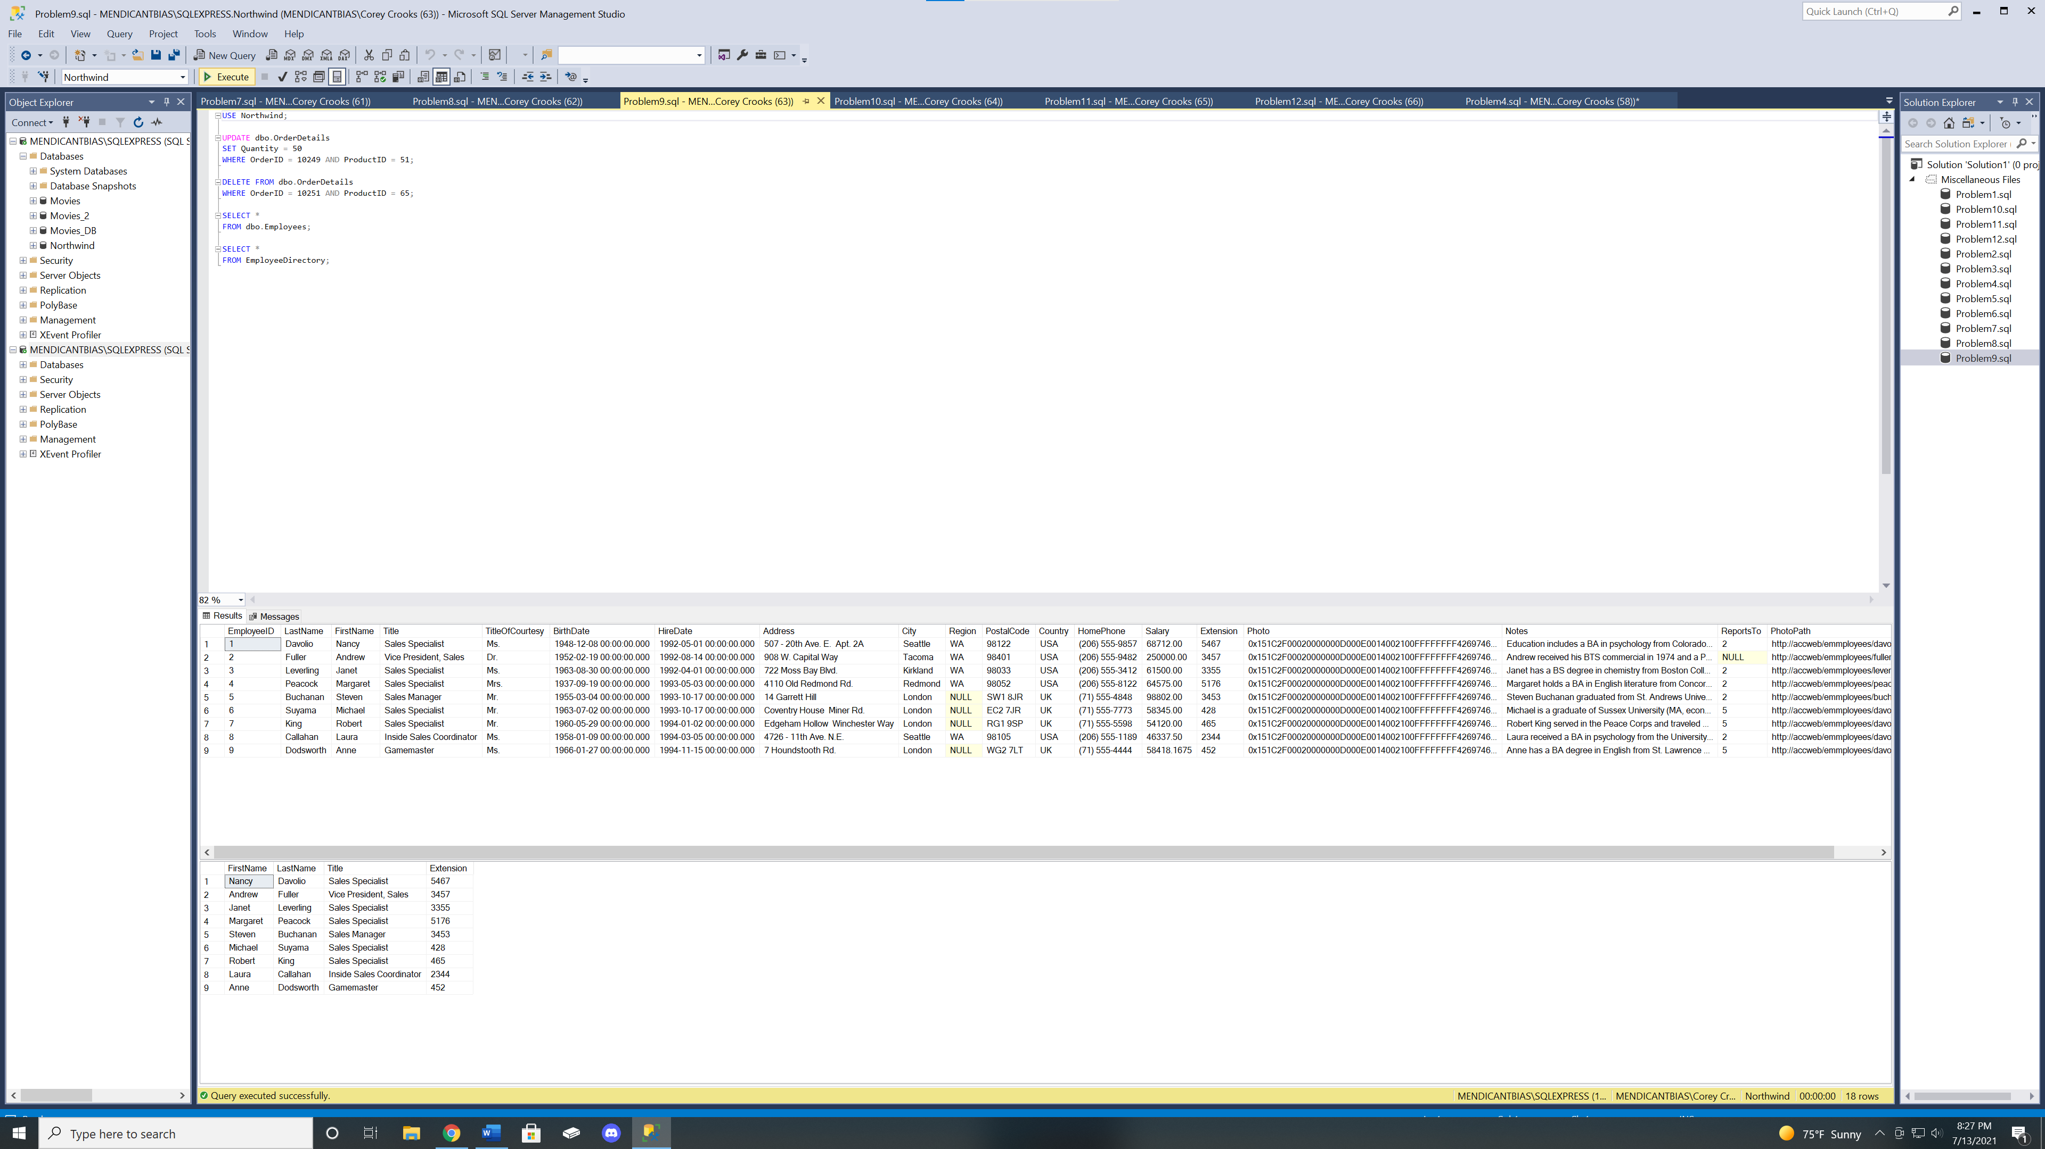

Due to the permissions Jane has as a sales person from problem 8, this output is nominal. She has access to SELECT, INSERT, UPDATE.

Problem 10

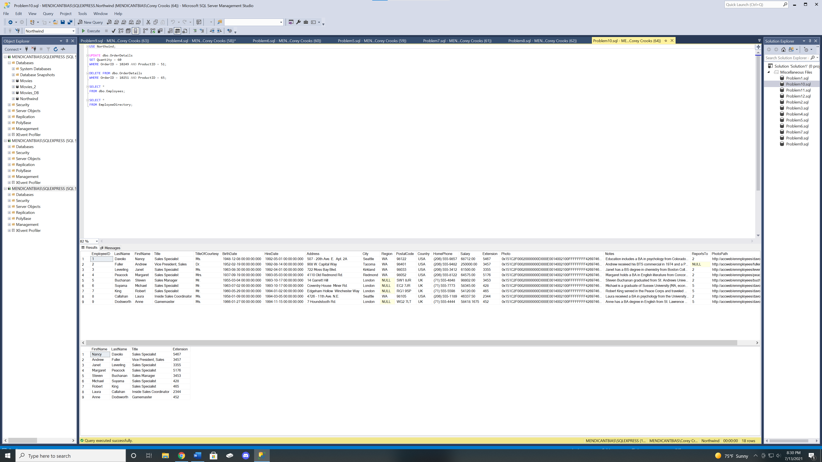

Due to the permissions Joan has as a sales manager that we set in problem 8, this output is nominal. She has access to SELECT, DELETE.

Problem 11

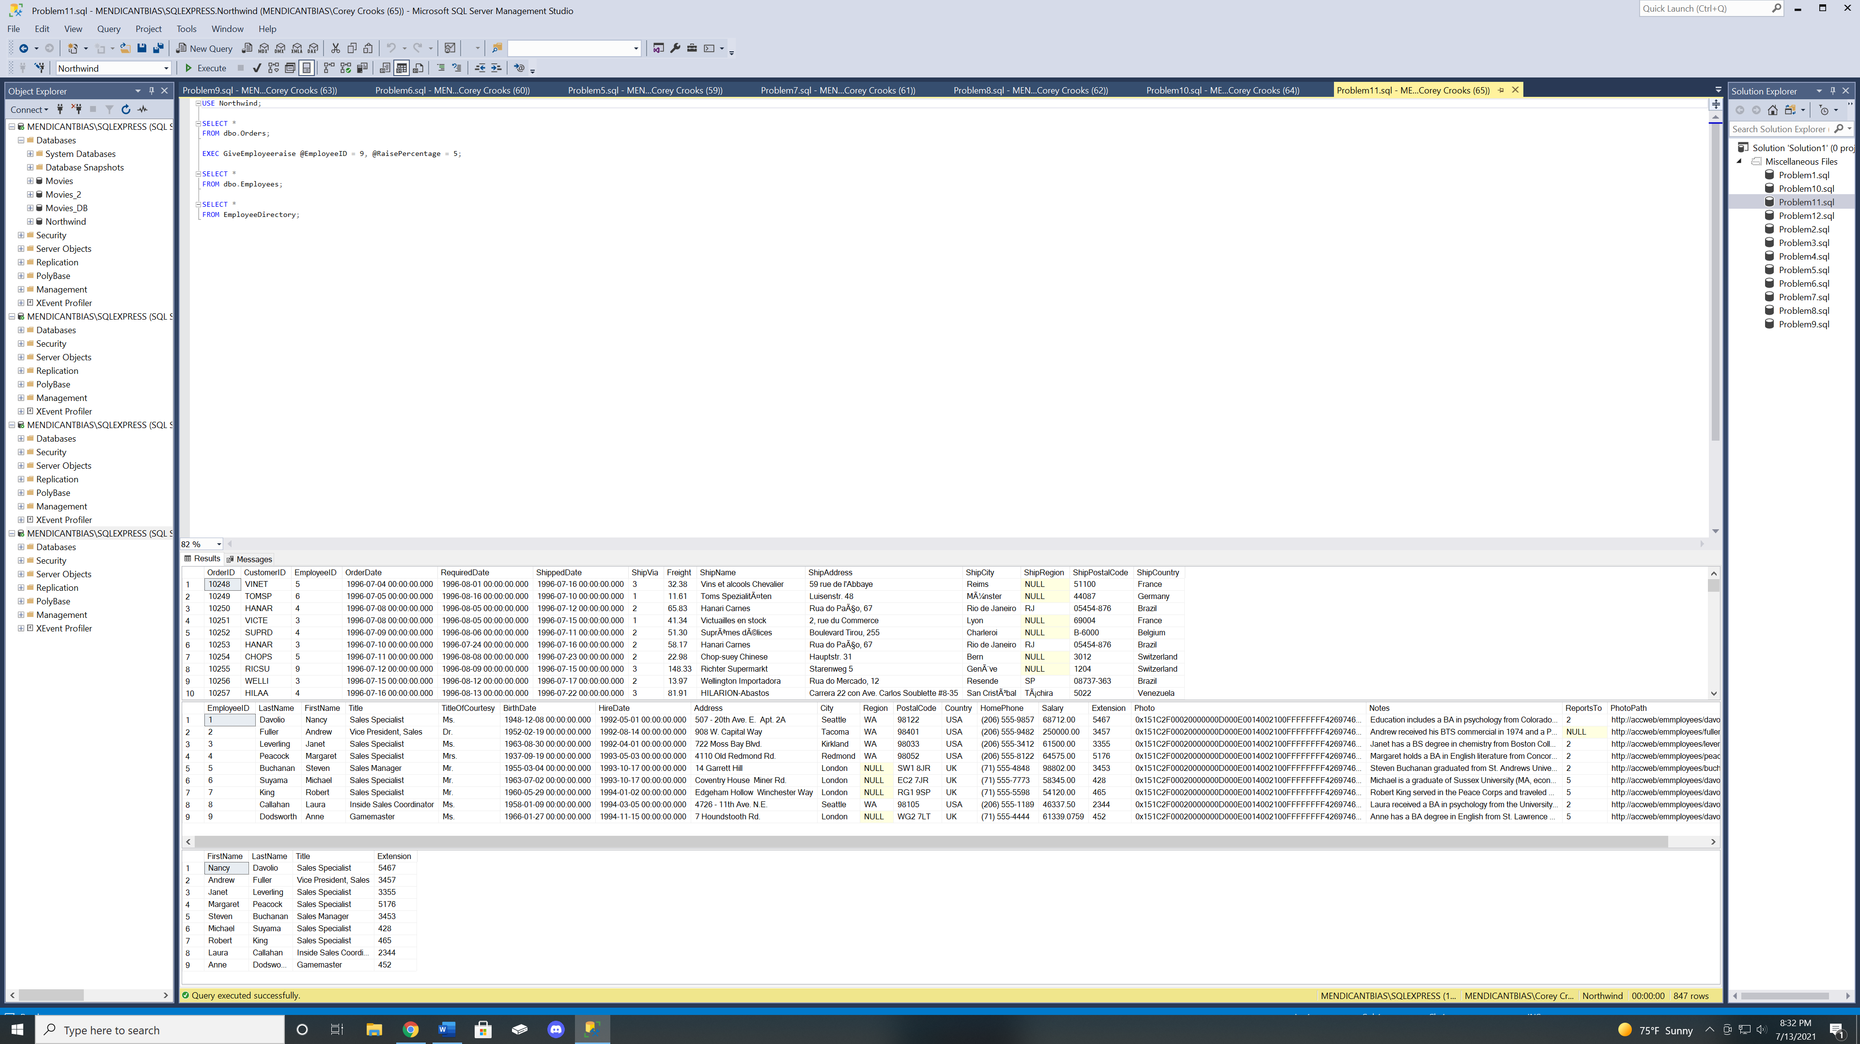

Due to the permissions Joe has as an HR Manager that we set in problem 8, this output is nominal. He has access to SELECT, INSERT, UPDATE.

Problem 12

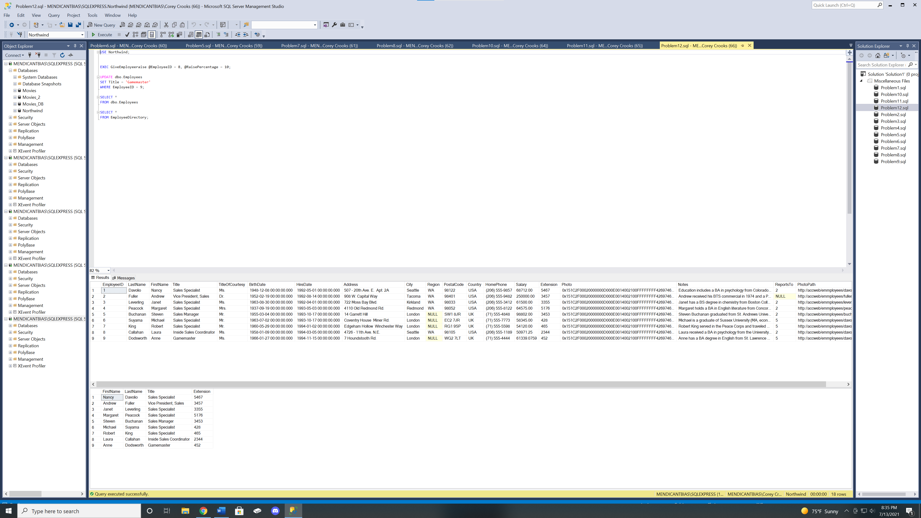Due to the permissions Joe has as an HR Manager that we set in problem 8, this output is nominal. He has access to SELECT, DELETE.